CHAPTER 14 BITMAPS AND BITBLTS

Unveiling the World of Bitmaps and Bitblts in Windows

This chapter dives into the fascinating realm of bitmaps and bitblts, essential tools for manipulating and displaying images in Windows applications. Let's embark on a journey through their intricate workings:

What are Bitmaps?

Imagine a rectangular grid overlaid on an image. Each tiny square within this grid represents a pixel, the basic unit of visual information.

A bitmap, in its simplest form, is a two-dimensional array of bits corresponding to these pixels. Each bit value determines the pixel's color or intensity, with 1 representing "on" and 0 representing "off."

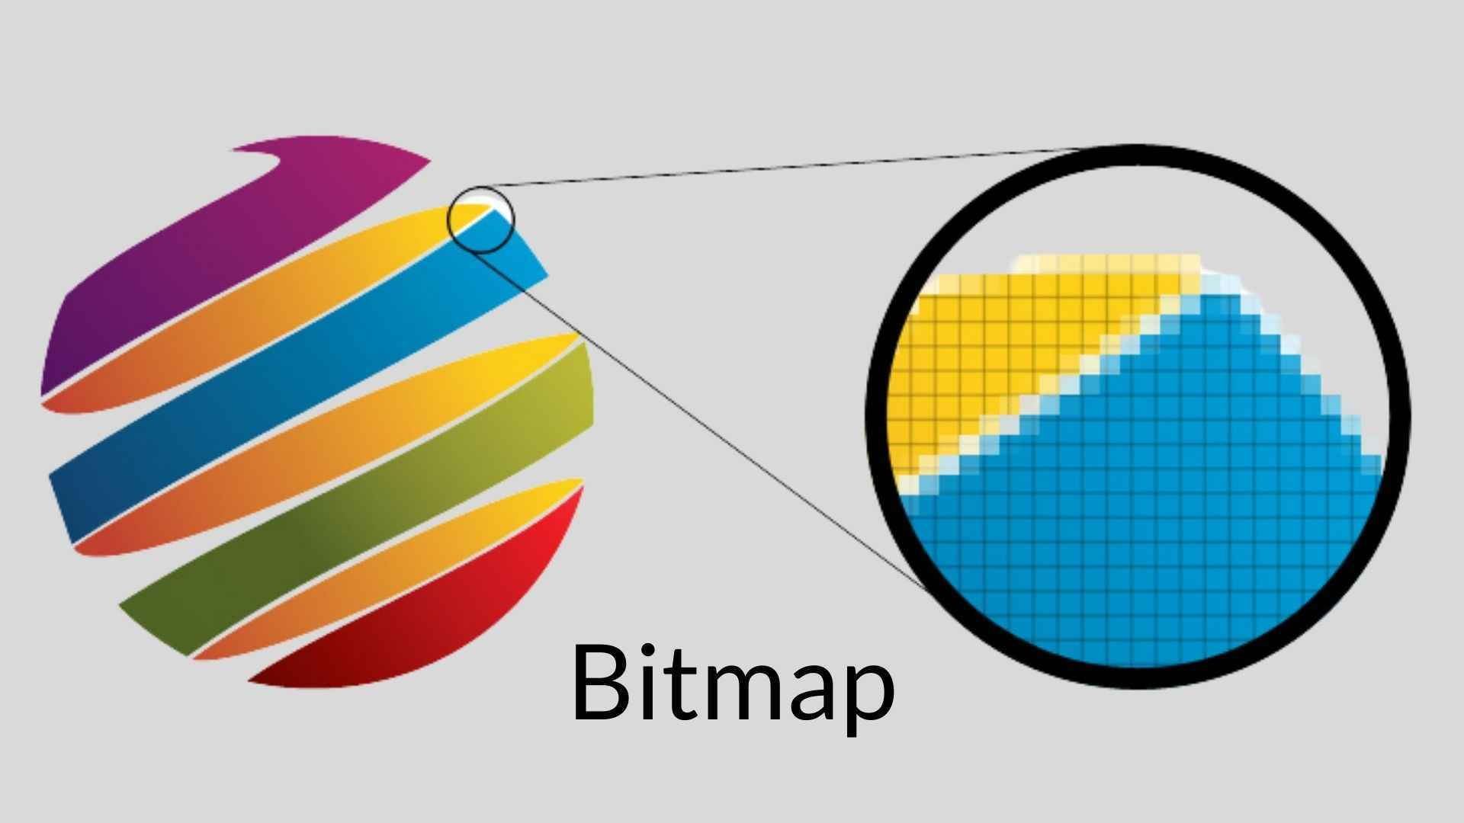

Shades and Colors: Beyond Binary

While monochrome bitmaps require just one bit per pixel, the world of images is often richer than black and white.

For shades of gray or vibrant colors, multiple bits per pixel come into play. Each bit acts as a tiny brushstroke, contributing to the overall color palette.

Think of it as a mosaic, where combinations of these individual bits build the intricate tapestry of the image.

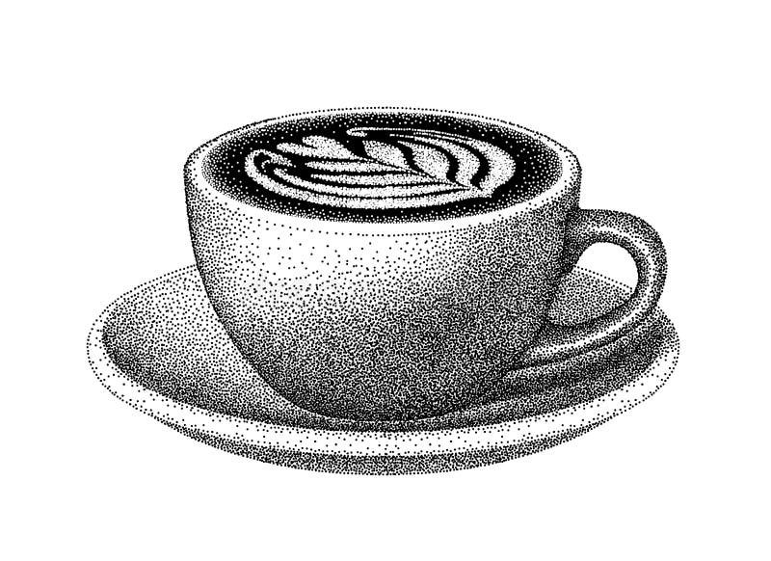

Bitmaps vs. Metafiles: Two Approaches to Pictorial Data

Windows offers two main approaches to storing pictorial information:

Bitmaps: As described above, bitmaps directly represent the digital image data, essentially a snapshot of the pixels and their colors. They are efficient for simple images but can become bulky for complex ones.

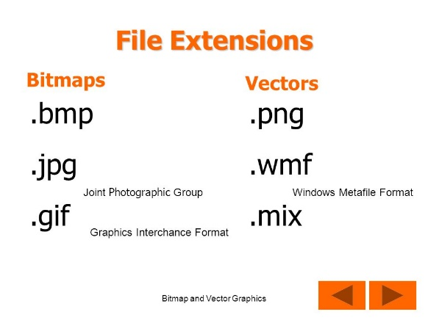 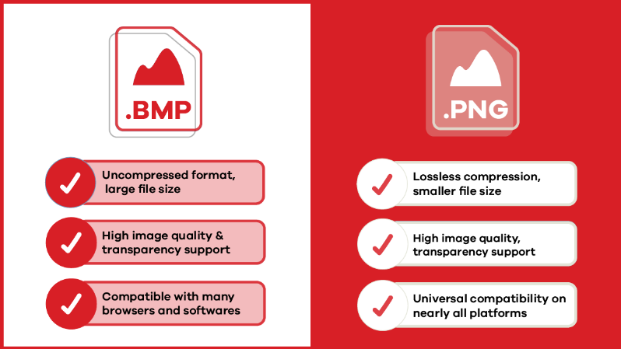

Metafiles: These store a set of instructions for drawing the image, similar to a recipe for creating the visual output. They are compact but require processing power to render the image on-screen.

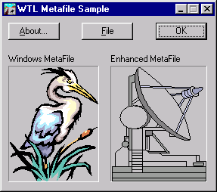

GDI Bitmaps: The Predecessors to DIBs

Before the introduction of device-independent bitmaps (DIBs) in Windows 3.0, GDI bitmaps reigned supreme. This chapter focuses on these pre-DIB bitmaps, showcasing their power and versatility even in the face of their later counterparts. Don't underestimate their value!

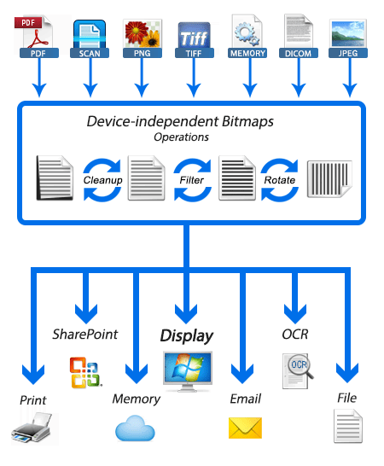

Bitblts: The Magic of Copying and Combining Images

Bitblts, short for bit block transfers, are the workhorses of image manipulation in Windows. They allow you to copy or combine rectangular regions of bitmaps, essentially transferring blocks of pixels from one location to another. Think of them as the paintbrushes and palettes of the digital world, enabling you to blend, move, and manipulate images with precision.

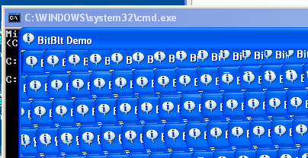

Exploring the Chapter's Depths:

Through a series of sample programs, this chapter delves deeper into the practical applications of GDI bitmaps and bitblts. You'll learn how to:

* Create and manipulate bitmaps using GDI functions.
* Load and display images from various formats like BMP and ICO.
* Copy and move portions of images using bitblts.
* Combine multiple images into a single composition.
* Apply transparency effects to create layered visuals.

Beyond the Basics:

This chapter lays the foundation for further exploration. You can dive deeper into topics like:

* Advanced bitblt operations for sophisticated image manipulation.
* Optimizing bitmap performance for efficient memory usage.
* Leveraging DIBs for device-independent image handling.

Embrace the Power of Bitmaps and Bitblts:

By understanding the concepts presented in this chapter, you unlock a powerful toolset for creating visually compelling applications in Windows. Remember, bitmaps and bitblts are not relics of the past; they remain valuable building blocks for modern image-centric applications. So, grab your digital paintbrush and start exploring the boundless possibilities of these fascinating tools!

DELVING DEEP INTO BITMAPS AND METAFILES: UNVEILING THEIR STRENGTHS AND WEAKNESSES

The digital world of images thrives on two distinct approaches: bitmaps and metafiles. Each holds its own advantages and drawbacks, shaping the way we create, manipulate, and share visual information. Let's dive deeper into their characteristics to understand their unique strengths and weaknesses:

Bitmaps: Capturing the Nuances of the Real World

Direct Representation: Imagine a detailed photograph. A bitmap captures it by meticulously recording the color or intensity of each tiny pixel, creating a digital replica of the real world with remarkable accuracy. This makes them ideal for complex images like scanned documents, photographs, and video captures.

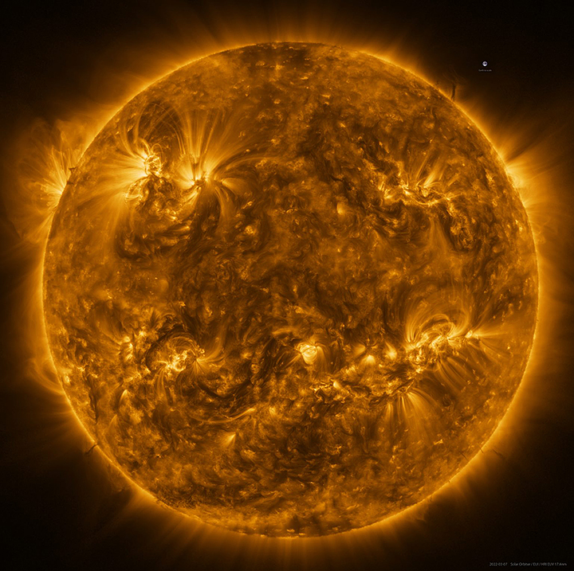

Device Dependence: However, bitmaps come with a caveat – their close ties to specific devices. Colors might appear washed out on a monochrome display, and scaling often leads to distortion due to pixel manipulation.

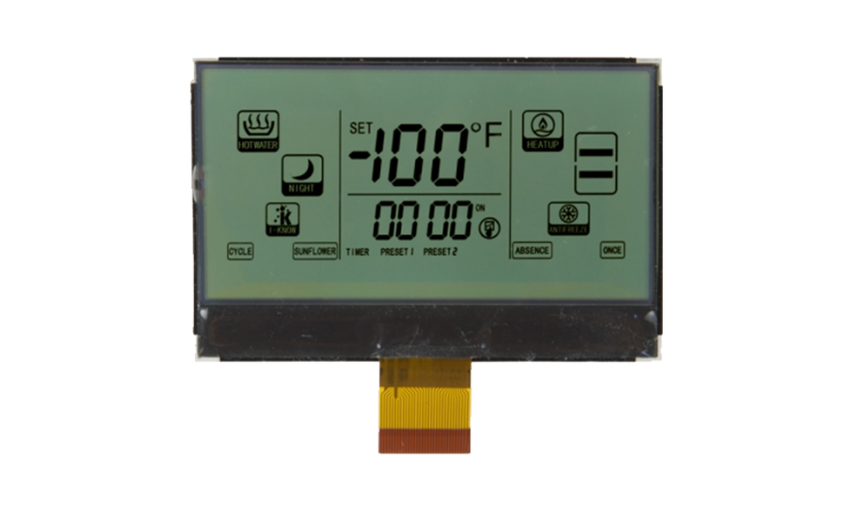

Storage Demands: The sheer amount of data required to represent every pixel can be substantial. A high-resolution image can easily consume megabytes of storage, posing challenges for transmission and archiving.



Metafiles: A Recipe for Scalability and Flexibility

Instructions, not Pixels: Unlike bitmaps, metafiles don't store the actual image data. Instead, they act like recipes, containing a series of instructions for drawing lines, shapes, and fills. This offers several advantages:

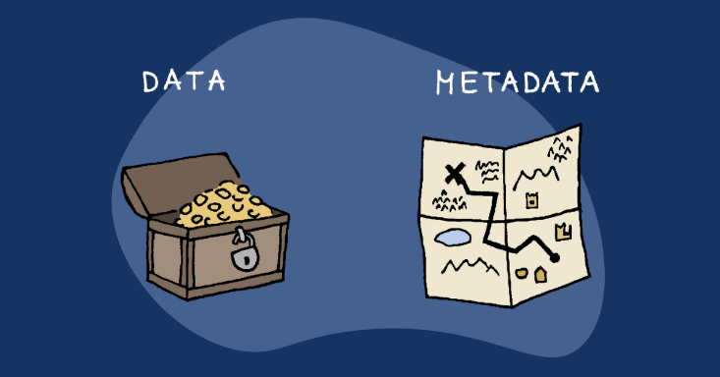

Device Independence: Metafiles can adapt to different devices and resolutions without distortion. The "recipe" adjusts automatically, ensuring consistent appearance across various displays and printers.

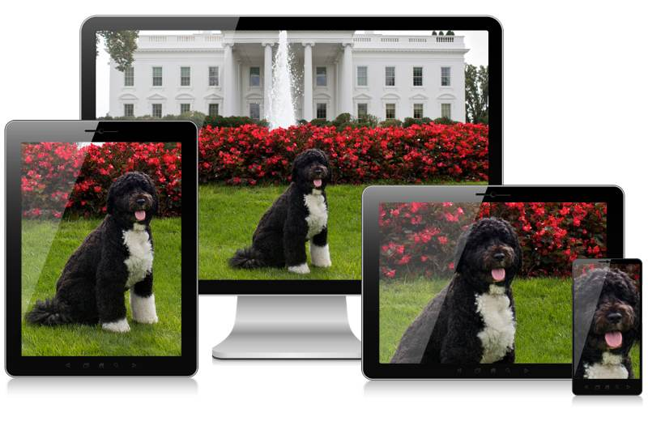

Scalability: Need a bigger image? Metafiles can be scaled up or down seamlessly without compromising quality, making them perfect for architectural drawings and diagrams.

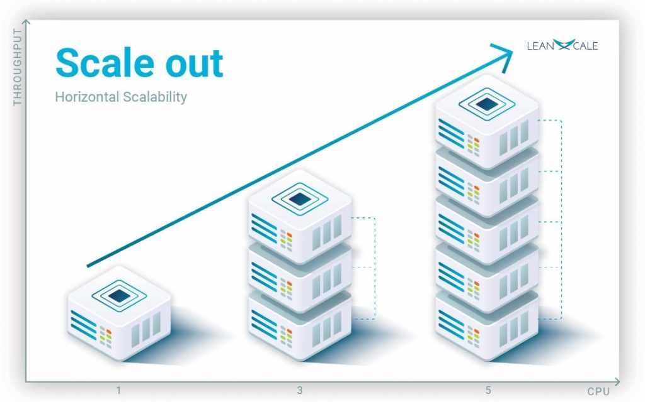

Compact Size: Compared to bitmaps, metafiles often require significantly less storage space. The instructions themselves are relatively small, making them ideal for sharing and transmission.

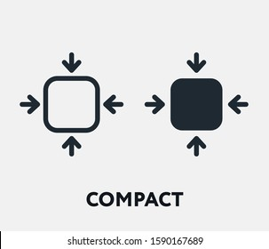

The Trade-off: Speed vs. Complexity

Speed Demon: When it comes to displaying simple images, bitmaps reign supreme. Copying a bitmap to the screen is a quick and efficient process, making them ideal for fast-paced applications like games and animations.



Processing Power: Metafiles, on the other hand, require more processing power to interpret their instructions and translate them into actual pixels. This can lead to slower rendering, especially for complex images.

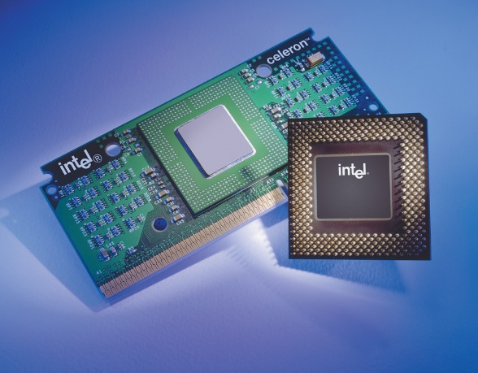

Beyond the Basics: Compression and Evolution

Compression Techniques: The storage demands of bitmaps have been addressed by compression algorithms. These algorithms can significantly reduce file size without sacrificing image quality, making bitmaps more manageable for transmission and storage.

DIBs and Beyond: The world of bitmaps continues to evolve. Device-independent bitmaps (DIBs) offer enhanced flexibility and device independence, while more advanced formats like JPEG and PNG provide efficient compression for various image types.

Choosing the Right Tool for the Job:

Understanding the strengths and weaknesses of both bitmaps and metafiles empowers you to make informed decisions about which approach to use. Consider factors like:

* Image Complexity: For intricate real-world images, bitmaps offer unmatched detail.
* Scalability and Flexibility: Metafiles shine when consistent appearance and adaptability are key.
* Storage and Transmission: If file size is a concern, metafiles generally take up less space.
* Performance: For fast-paced applications, the speed of bitmaps might be crucial.

Conclusion:

Bitmaps and metafiles are not rivals, but complementary tools in the digital artist's toolbox. Understanding their unique strengths and limitations allows you to leverage their power to create visually stunning and effective applications. So, choose wisely, experiment creatively, and let your imagination take flight in the world of digital images!

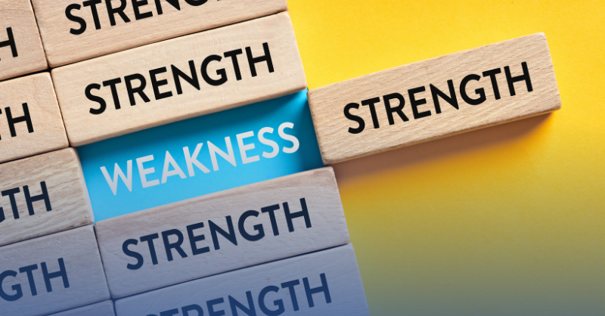

I hope this more in-depth explanation clarifies the differences and nuances between bitmaps and metafiles. Feel free to ask further questions or request specific aspects for deeper exploration! Remember, there's always more to discover in the fascinating world of computer graphics.

THE DIVERSE ORIGINS OF BITMAPS: A JOURNEY FROM MANUAL CREATION TO CAPTURED REALITY

Bitmaps, those ubiquitous building blocks of digital images, have a fascinating journey before they grace our screens. Their origins lie not only in the creative minds of artists but also in the intricate workings of hardware and the wonders of the real world. Let's delve into the diverse ways bitmaps come to life:

1. From the Artist's Brush to the Digital Canvas:

Manual Creation: Programs like Paint allow artists to directly create bitmaps. Each brushstroke, each pixel placed, becomes part of the final image. This approach is ideal for intricate details and artistic expression, where precise control over individual pixels is paramount.

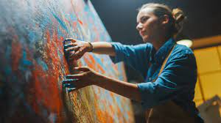

2. Algorithmic Magic:

Code-Crafted Images: Not all bitmaps need a human touch. Computer code can generate intricate patterns, textures, and even fractals, often too complex to be rendered as vectors. These algorithmically generated landscapes and abstract creations push the boundaries of digital art.

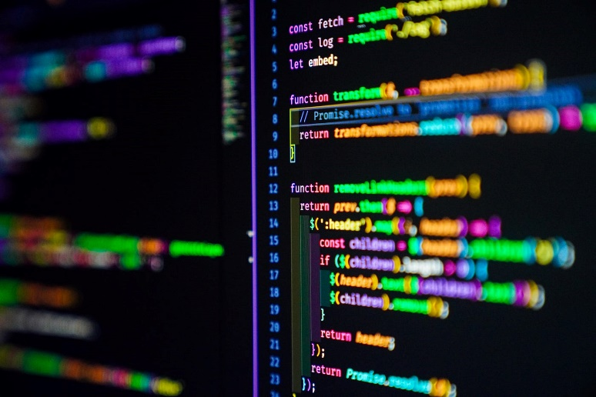

3. Capturing the Real World:

Hardware Heroes: This is where bitmaps truly shine, capturing the essence of the physical world. Hardware devices like scanners, camcorders, and digital cameras bridge the gap between reality and the digital realm.

Scanners: The veterans of the field, scanners use rows of CCD (charge-coupled device) cells to scan images, translating light intensity into electrical charges, then into digital values. With each scan, a line of pixels is captured, building the final bitmap representation of the scanned image.

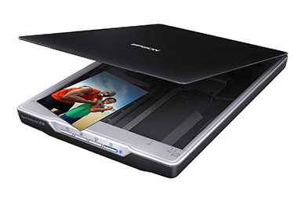

Camcorders: These video capture devices employ CCD arrays to capture video frames, which can be stored on tape or, more recently, converted directly into bitmaps using video frame grabbers. This allows you to grab individual frames from videos, creating still images from your favorite movies or TV shows.

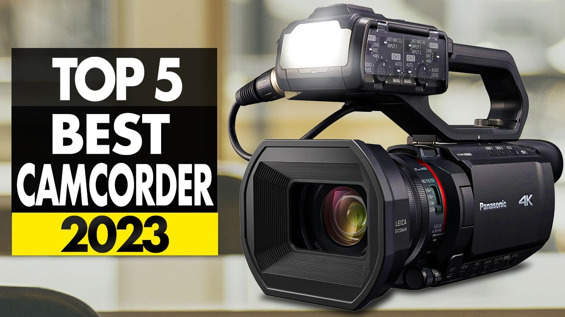

Digital Cameras: The latest stars of the show, digital cameras have made capturing bitmaps accessible and affordable. Their internal CCD arrays and ADCs convert light directly into digital images, stored within the camera itself. These images can then be transferred to computers for editing, sharing, and creative exploration.

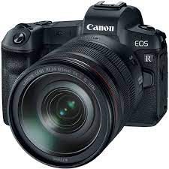

Beyond the Basics:

Beyond CCDs: While CCDs are the dominant technology, other sensors like CMOS (complementary metal-oxide-semiconductor) are also used in image capture devices.

Image Compression: The quest for efficient storage has led to various compression algorithms that reduce bitmap file size without sacrificing significant image quality.

The Future of Bitmaps: As technology advances, expect even higher resolutions, faster capture speeds, and even more sophisticated algorithms for generating and manipulating bitmaps.

Conclusion:

* Bitmaps are not just pixels on a screen; they represent diverse creative expressions, captured moments from the real world, and the ever-evolving landscape of digital imaging technology.
* So, the next time you encounter a bitmap, take a moment to ponder its journey – from the artist's canvas, the intricate workings of a scanner, or the fleeting moment captured by a camera lens.
* Each bitmap tells a story, a testament to the creative power of humans and the ever-evolving world of digital imagery.

DEMYSTIFYING BITMAP DIMENSIONS: A DEEP DIVE INTO WIDTH, HEIGHT, AND COORDINATES

When it comes to bitmaps, understanding their dimensions is crucial. It's the foundation upon which their visual information rests, dictating their size, resolution, and even interaction with other elements. Let's delve deeper into the fascinating world of bitmap dimensions:

Rectangular Wonders:

At their core, bitmaps are rectangular grids of pixels, each representing a tiny dot of color or intensity. This grid defines the image's spatial dimension, measured in pixels: width and height.

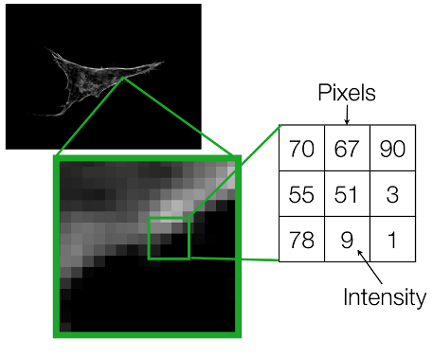

Shorthand Notation:

To avoid cumbersome phrases, we often use a concise notation for a bitmap's dimensions. For instance, "9 by 6" describes a bitmap 9 pixels wide and 6 pixels high. Remember, the width comes first by convention.

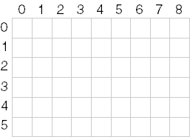

Pixel Power:

The total number of pixels in a bitmap is calculated by multiplying its width and height. In our example, 9 pixels x 6 pixels = 54 pixels. We often use cx and cy (count x and count y) to represent width and height, respectively.

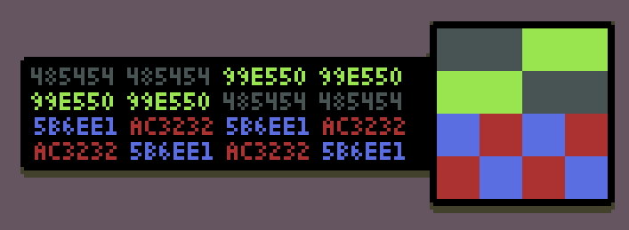

Coordinates: Pinpointing Pixels:

Each pixel within a bitmap holds its own unique location, identified by its x and y coordinates. By convention, the upper left corner is considered the origin (0, 0). Following this system, the bottom right pixel in our 9x6 example would be located at (8, 5) – one less than the width and height because numbering starts at zero.

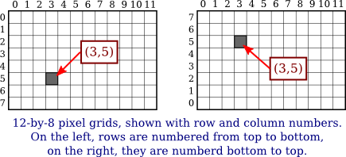

Resolution: A Confusing Term:

The term "resolution" can be tricky when discussing bitmaps. It can refer to both:

* Display Resolution: This refers to the number of pixels a display device like a monitor can show, often expressed as "640x480".
* Pixel Density: This refers to the number of pixels per unit of measurement, like "300 dots per inch" for a printer.

For bitmaps, focusing on pixel density as "resolution" provides a clearer understanding of their detail level.

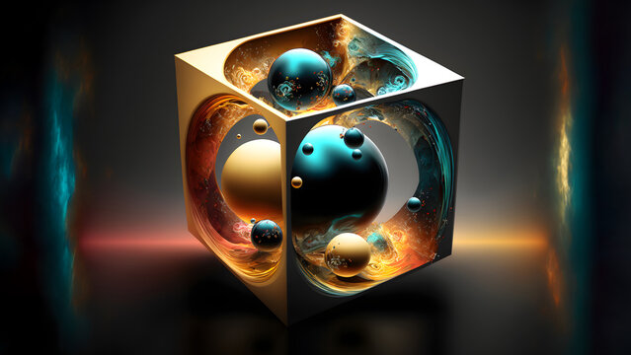

Memory Maze: Storing Bitmaps Linearly:

While bitmaps are rectangular, our computers store information linearly. Therefore, bitmaps are typically stored in memory row by row, starting with the top row and ending with the bottom. Each row, in turn, stores pixels from left to right, mimicking how we write lines of text.

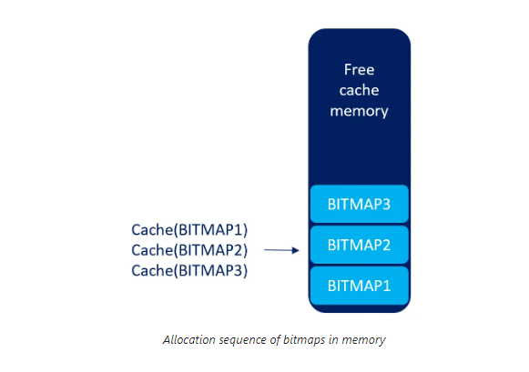

The Exception: DIBs and Beyond:

It's important to note that not all bitmaps conform to this linear storage model. Device-independent bitmaps (DIBs), for instance, store information differently, offering greater flexibility and device independence.

Understanding Dimensions: A Key to Success:

Grasping a bitmap's dimensions is essential for various tasks:

Scaling and manipulating images: Knowing the width and height allows for proper resizing and adjustments without distortion.

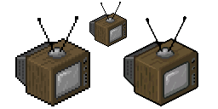

Extracting specific pixels: Coordinates enable access and manipulation of individual pixels within the bitmap.

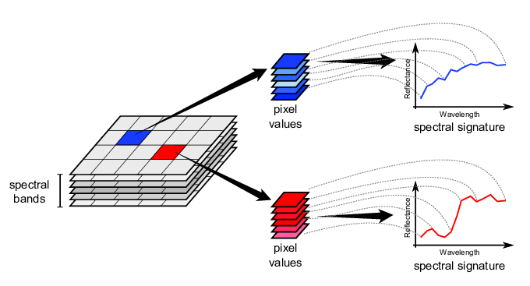

Aligning with other elements: Understanding dimensions becomes crucial when placing bitmaps alongside other visual elements within an application or user interface.

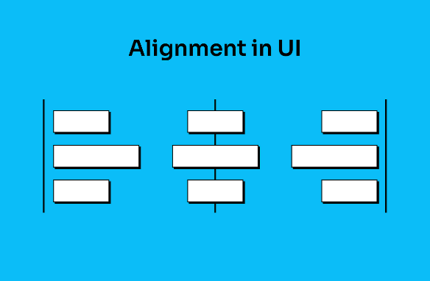

UNVEILING THE MYSTERY OF COLOR IN BITMAPS: A DEEP DIVE INTO BIT DEPTHS AND PALETTE MAGIC

Beyond their width and height, bitmaps possess another crucial dimension – color. This dimension, defined by the number of bits allocated to each pixel, determines the richness and complexity of the visual information they can display. Let's explore the fascinating world of color within bitmaps:

Bit Depth: The Language of Color:

Each pixel in a bitmap speaks the language of bits. The number of bits assigned to it, known as the bit depth or color depth, determines how much color information it can carry. This depth acts like a vocabulary, defining the range of colors a pixel can express.

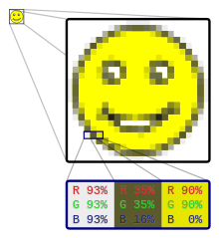

Monochrome Masters: Bilevel and Beyond:

At the simplest level, a bitmap can have just one bit per pixel, making it a "bilevel" or "monochrome" image.

This binary world allows only two states: on (typically white) or off (typically black). While seemingly limited, these monochrome masters excel in sharp lines, intricate patterns, and classic artistic expressions.

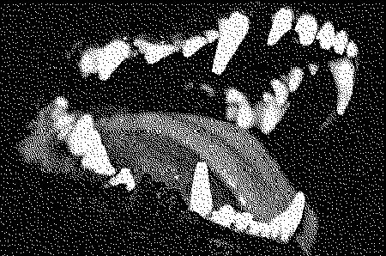

Beyond Black and White: Expanding the Palette:

With more bits come more colors. Each additional bit doubles the potential color combinations, opening doors to a richer palette. Two bits offer four colors, four bits offer sixteen, and so on. This exponential growth allows bitmaps to paint a broader spectrum of the world around us.

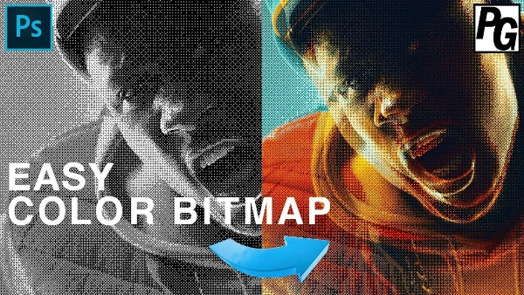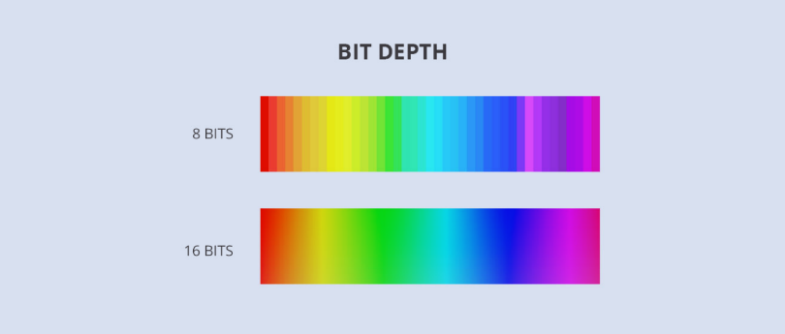

The Magic of 8-bit Palettes: A Familiar Canvas:

For decades, the 8-bit world reigned supreme in digital art and early computing. With 256 possible colors, it struck a balance between complexity and practicality. Artists crafted vibrant palettes, each pixel carefully chosen to depict landscapes, characters, and objects in a captivatingly pixelated style.

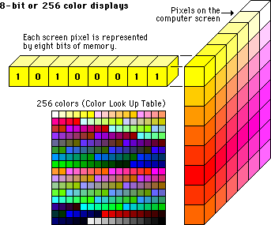

Pushing the Boundaries: 16-bit, 24-bit, and Beyond:

The quest for photographic realism led to higher bit depths. 16-bit bitmaps offered a staggering 65,536 colors, while 24-bit bitmaps, the standard for modern displays, boast a mind-boggling 16.7 million colors! This vast palette allows for near-photorealistic images, blurring the line between the digital and the real.

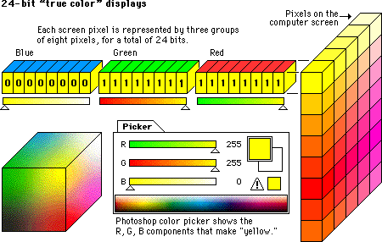

Decoding the Color Code: From Bits to Familiar Hues:

But how do these bits translate into actual colors? This is where the magic of color mapping comes into play. Each combination of bits corresponds to a specific index in a palette, a collection of pre-defined colors.

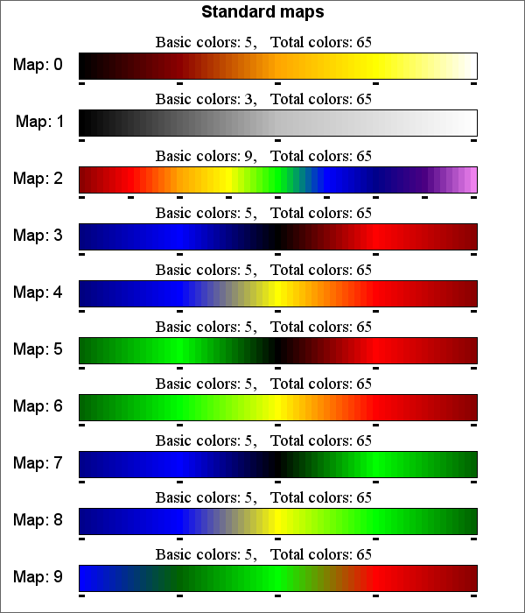

The operating system or application maintains this palette, and the bitmap simply references the indexes to paint its pixels. Understanding this mapping system empowers you to manipulate palettes, create custom color worlds, and inject your own artistic vision into your bitmaps.

Beyond the Basics: Dithering, Transparency, and More:

The world of color in bitmaps is vast and ever-evolving. Techniques like dithering simulate additional colors with limited bit depths, while transparency allows bitmaps to blend seamlessly with other visual elements. The possibilities are as limitless as your imagination.

